ECE 403: Design II

**Options Considered Document**

03/01/2015

James Massey

Dale Bromenshenkel

Bradley Hoffmann

**Options Considered Document**

**Introduction**

Learning new skills is an essential part of developing as humans. It can often be difficult to pick up new skill such as learning how to play the guitar, or shooting pool. Commonly, these skills are learned by taking a class from an instructor who already has the skill. This can take years of practice, and sometimes might not end in the desired results. The goal of our project is to create a system which will help people learn new skills effectively through the use of virtual reality. Our team hopes to achieve this goal through the use of light projection. We have dubbed the term “Projected Reality” to describe the product.

The focus of this project will be designing a projection unit consisting of a projector and a tablet which will project ball positions as well as other supplementary data to a pool table.

**Previous Work**

*Laser Projected Keyboard*

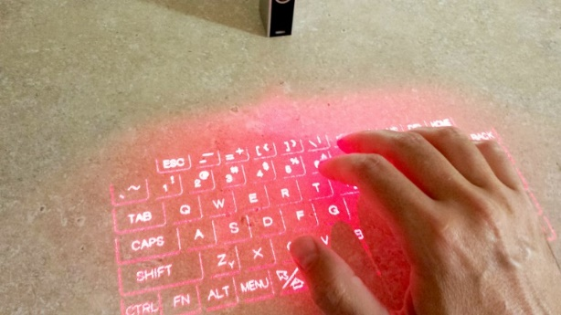

The Celluon Epic projection keyboard is not used for learning a new skill, but does aim to project the reality of a keyboard onto surfaces.

The Celluon Epic projection keyboard is a laser projected keyboard which can be projected on any surface and used as a regular keyboard. The keyboard can even be used as a mouse/touchpad for windows PC and Mac. It can be used with any Bluetooth capable device by syncing with the device. The device emits an infrared light along with the lasers. When an object such as a finger obstructs the light over a key, it detects the key pressed and converts it to a keystroke. The device is small, and can fit inside of a pocket. It is compatible with iOS, Android, Windows, and Mac OS X. The device costs around $150 on Amazon.

The device is still going through development, and is currently still a bit buggy. The company hopes to release a working product in the coming years.

<http://www.gizmag.com/celluon-epic-laser-keyboard-review/28342/>

*Cassapa: Augmented Pool*

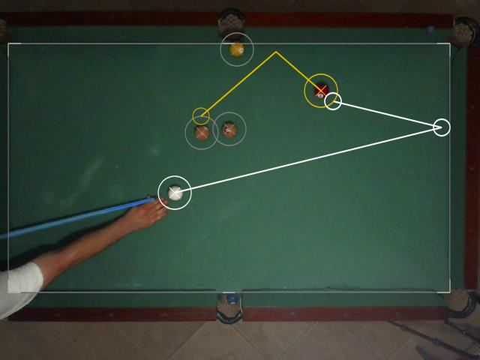

The cassapa pool table is an augmented reality pool table that uses a projector and a webcam. Onboard software marks the position of the balls, border, then processes that data and spits it back out through the projector. The onboard software can calculate physics real time allowing for accurate shots. The team mentions integrating the onboard software into a platform such as Google Glass to give the user eye level data.

<http://hackaday.com/2014/02/05/cassapa-augmented-pool/>

*Pool-Playing Robot + ARpool*

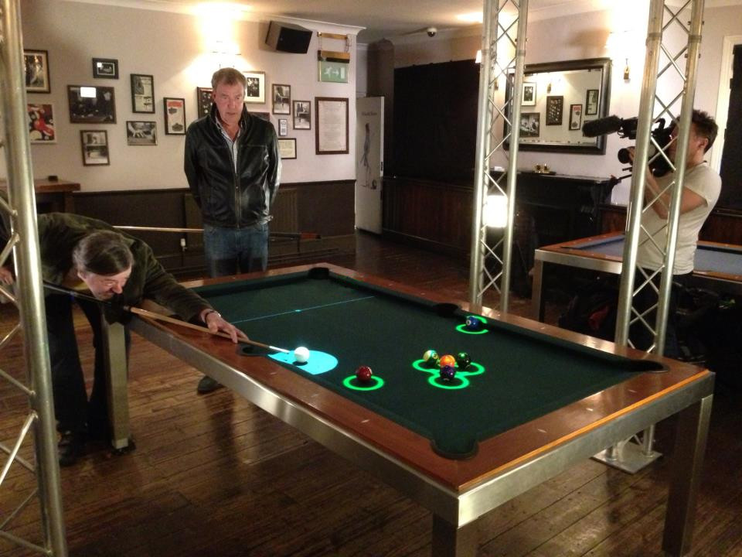

Members of Queen’s University have combined their Deep Green Robot with a camera and image processing. The robot is able to use a ceiling mounted Canon 350D along with an onboard computer to make a near unbeatable pool robot.

Another project being worked on at Queen’s University is ARpool: an augmented reality image processing+projector project which aims to help inexperienced players learn how to play pool. The table is able to read the table using a camera, then process that data with an onboard computer and output to a projector.

<http://arpool.ca/>

*Topshop Kinect Dressing Rooms*

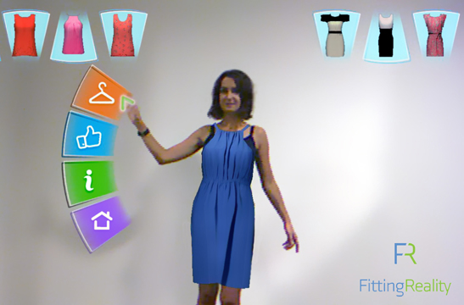

Trying on clothes can be a very long and tedious process. Topshot’s Kinect Dressing room aims to use augmented reality to create a more efficient clothes shopping experience. The product uses a Microsoft Kinect to read body movement and shape. Along with showing the user their appearance with a certain garment, the Kinect dressing room also has different button controls. The user can access these controls by putting the hand on the button that they wish to press. The final product was installed at the flagman Topshop store in Moscow. They hope to fine tune the program to create a more accurate appearance.

<http://www.wired.com/2011/05/augmented-reality-kinect-fitting-room-for-topshop-moscow/>

**Design Options & Selected Work**

The scope of our project allows us to select from a great deal of products. The following section will outline which options we have considered for our project, and which we believe is the best avenue to take.

The following components exist in our project:

* Image Input (Camera)
* Image Output(Projector)
* User Application
* Image Processing

*Image Input(Camera)*

Our final product will need image input in order to process the output. There are many different image input devices that exist on the market.

Tablets:

Tablets are a camera and much more. With any tablet we will be able to take in images using built in camera control. We will also have the ability to use all of the other sensors built into a tablet. Most tablets have enough processing power for the data that we will be using, and applications can be developed onto the tablet. Another nice feature of tablets is that we can push software updates to users through a distributed store app. This also means that users will be able to use their existing tablets saving us hardware development costs.

Samsung Galaxy Tab 4 Series:

The Samasung Galaxy Tab 4 series is a great Android based tablet with many different customizable features. Processor speed is around 1.2Ghz with 16+GB storage capacity. The tablet also has a 3.0MP rear-facing and 1.3MP front-facing camera. If the storage capacity is not enough for you, you can expand up to 64GB using the microSD slot. The Tab 4’s also have built in stereo speakers in case we ever need to export audio.

<http://www.bestbuy.com/site/samsung-galaxy-tab-4-10-1-wi-fi-4g-lte-16gb-at-t-black/7273007.p?id=1219262036061&skuId=7273007>

Samsung Galaxy Tab S Series:

The Tab S series is similar to the Tab 4 series, but boasts a bigger screen, 2x internal storage and microSD slot, two quad core processors, dual 2.1MP/8.0MP cameras, and the ability to manage two apps simultaneously.

<http://www.bestbuy.com/site/samsung-galaxy-tab-s-10-5-32gb-titanium-bronze/7093009.p?id=1219250430282&skuId=7093009>

Apple Ipad Air 2

Apple products generally run magnificently, and the Ipad Air 2 is no exception. It boasts an 8MP iSight camera, uses a powerful A8X chip with 64-bit architecture and an impressive 10 hours of battery life. One drawback of the Ipad Air 2 is the requirement of building code on a Mac. No one on the team has much experience with Mac OS, and the market for Android is rapidly growing. Another con of the Ipad Air 2 is the price at a painful $599.

<http://www.bestbuy.com/site/apple-ipad-air-2-wi-fi-64gb-gold/3315023.p?id=1219090215027&skuId=3315023>

Dedicated Cameras:

Cameras dedicated to video recording generally boast much more recording power than tablets. The increase in video quality is balanced with the fact that another computer/processing component will be needed in order to use the camera.

GoPro Hero4 Series

If you have seen any head mounted or extreme footage, there is a good chance it was shot with a GoPro camera. GoPro makes high quality, durable cameras which have a variety of mounts to let you be creative in your filming. Pros of the GoPro for our project are 4k video, the ability to connect to Bluetooth, tons of existing mounts, and 12.0MP photo resolution. Cons of the GoPro are that it has a moderate amount of libraries behind it, and it costs as much as a tablet. If we went with the GoPro, we would still need an additional Bluetooth device to take in and process the GoPro footage real time. This would increase cost and development time, without increasing value much.

<http://www.bestbuy.com/site/gopro-hero4-silver-action-camera/8374096.p?id=1219329115702&skuId=8374096>

Logitech Webcam

Logitech is a company that makes great computer accessories for a great price. Their line of webcams can fit any consumers’ needs. The best webcam in their line is the C920 Logitech HD Pro Webcam. It can take 1080p@30FPS video, and has a 15.0MP Camera. The camera also comes with a lot of prepackaged software designed to give the consumer the best quality video recording. The connection is USB 2.0, so it can connect to any USB computer or device. At $99, the C920 is a very affordable, but effective camera.

Raspberry Pi & Camera

The Raspberry Pi Camera is a camera build to be used by the Raspberry Pi. It is a 5MP that can support up to 1080@30FPS. There are tons of python libraries that can be used with the camera, including an image processing library called OpenCV. The raspberry pi itself has a 700Mhz/900Mhz processor which is a little slower than the other choices, but still effective. One of the great features of the raspberry pi is the I/O. The raspberry pi has an hdmi port for 1080 video output, as well as 4 USB ports. Model B+ and above have 40 GPIO (General Purpose Input Output Pins) to perform Arduino like input and output. And lastly, the raspberry pi is basically a computer. It can do things that almost any desktop computer can do. The newest version can even run Windows 10, so if you are uncomfortable with Linux you can use windows.

***Image Input Conclusion***

The two most appealing choices for image input are the Samsung S series tablets and the Raspberry Pi+Camera.

The Samsung S series tablet has great specs that make it a great platform to start with. The processing power is perfect for our application, and the built in camera is high quality. Since the Tab S is android based, a lot of our project can be focused on an application which can be used by other android devices.

The Raspberry Pi+Camera combo has the advantage of development cost and existing libraries. OpenCV is a great image processing tool with lots of community support. The raspberry pi & camera cost around $60 which is far lower than the tablet cost of $299+. A hardware product would have a tougher time entering the commercial field than a software app as people generally like using their existing hardware over having to buy new software.

The image input that we will be using for our project will be through a tablet and an android application. The tablet has a much better processor, and will allow us to appeal to a much wider market. The raspberry pi has a lot of potential, but doesn’t quite have the specs of the tablet, and would require us to sell the raspberry pi hardware as well. It is much easier to sell an app than it is to sell new hardware.

The specific tablet that we will use for our project will be the Samsung Galaxy Tab S 10.5”. This tablet has almost double the specs of the Tab 4 with only $100 more in cost. It is also leading the way in tablet technology being one of the first tablets to support multiple applications at one time.

*Image Output(Projector)*

There are many different design options that will be considered with regards to projectors. Some of the key features that are important to our project are I/O, lumens, resolution, battery life, and price. I/O is important to us because it will allow us to connect to a multitude of devices. If a tablet is used the project will need to be able to connect to the tablet through micro usb. Bluetooth and other wireless technologies are a plus, but not necessary for our project. Lumens is the brightness that the projector has. Higher lumens equals higher brightness.

We originally wanted to use a smaller and more portable projector for this project, but upon further research we’re unsure if it is feasible for our required tasks. The main problem we have is the distance the projector is going to be from the pool table. The average ceilings are 8 feet tall and most tables are about 3 feet off the ground that gives us about 4-5 feet of distance from the table to the ceiling. We will use a 16:9 ratio for the projector image and pool tables are all built with a 2:1, so that’s about perfect. Most pool tables are about 8 feet long so designing for at least that would be the goal.

There is an equation that has to deal with a projectors distance from the surface they are projecting on and the width of the projection. The term for the result is called the throw ratio. We’ll design for 4 feet away and will want an 8 foot in width projection so using the equation

$$Throw Ratio= \frac{Distance from surface}{Projected width}$$

So applying the equation for our design requirements we get a throw ratio of .5.

$$.5= \frac{4ft}{8ft}$$

With a throw ratio of .5 that puts us in the category of projectors call “short throw” projectors.

Another option would be to incorporate a wide angled lens for the projector we choose. This would allow us to pick a smaller more portable projector, but the image may not be exactly what we’re shooting for as far as resolution.

Wide angle lens

ScreenStar

This is the only company that I found that makes wide angle lenses that attach onto projectors specifically. This company makes really nice lenses, but they are really expensive. The lens what we would want would be $3,150.00.

Camera lens

There are some people that were able to attach a wide angle camera lens to a projector and get good results, but the majority experienced a lot of distortion and rounded corners. We’d need a camera lens with a x.5 ratio or lower, most are x.43 or so. In the online discussion they talked about getting a lens with a macro attachment. This is an example of a lens that might work.

1. 58MM 0.43x Altura Photo Professional HD Wide Angle Lens ($27)

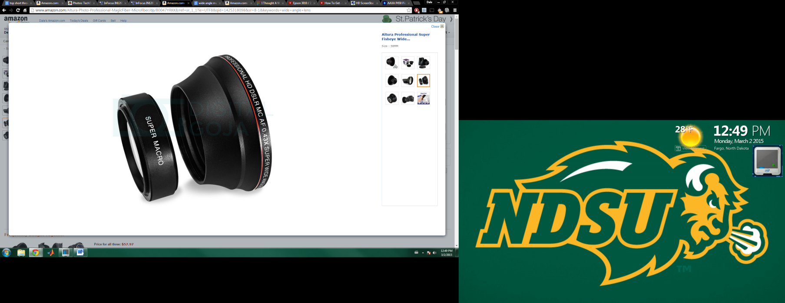

This lens has a x.43 ratio so it might be able to be attached to other projectors and create a wide viewing angle. This lens also has a macro attachment which would be needed.

Short throw projectors

Short throw projectors have the wide angle lens built right into them and are commonly used in smart board applications, or any application that requires a large image in a short space.

1. Mitsubishi XD365U-EST Extreme Short Throw 2500 Lumens Projector ($500)

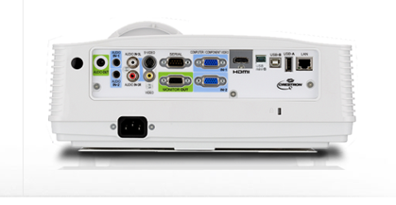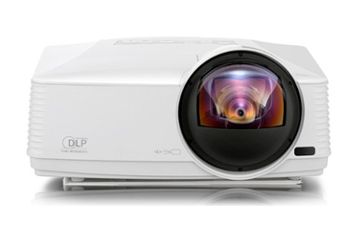

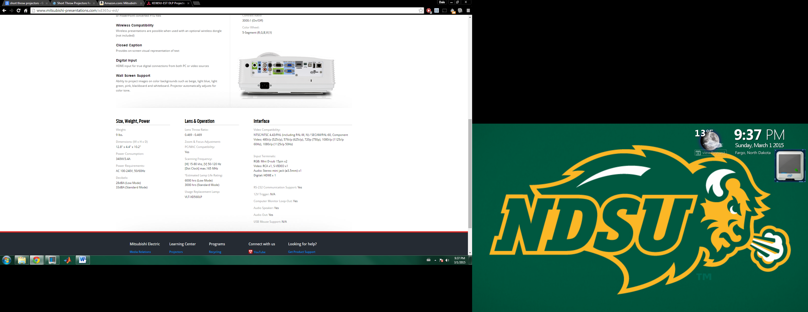

1. 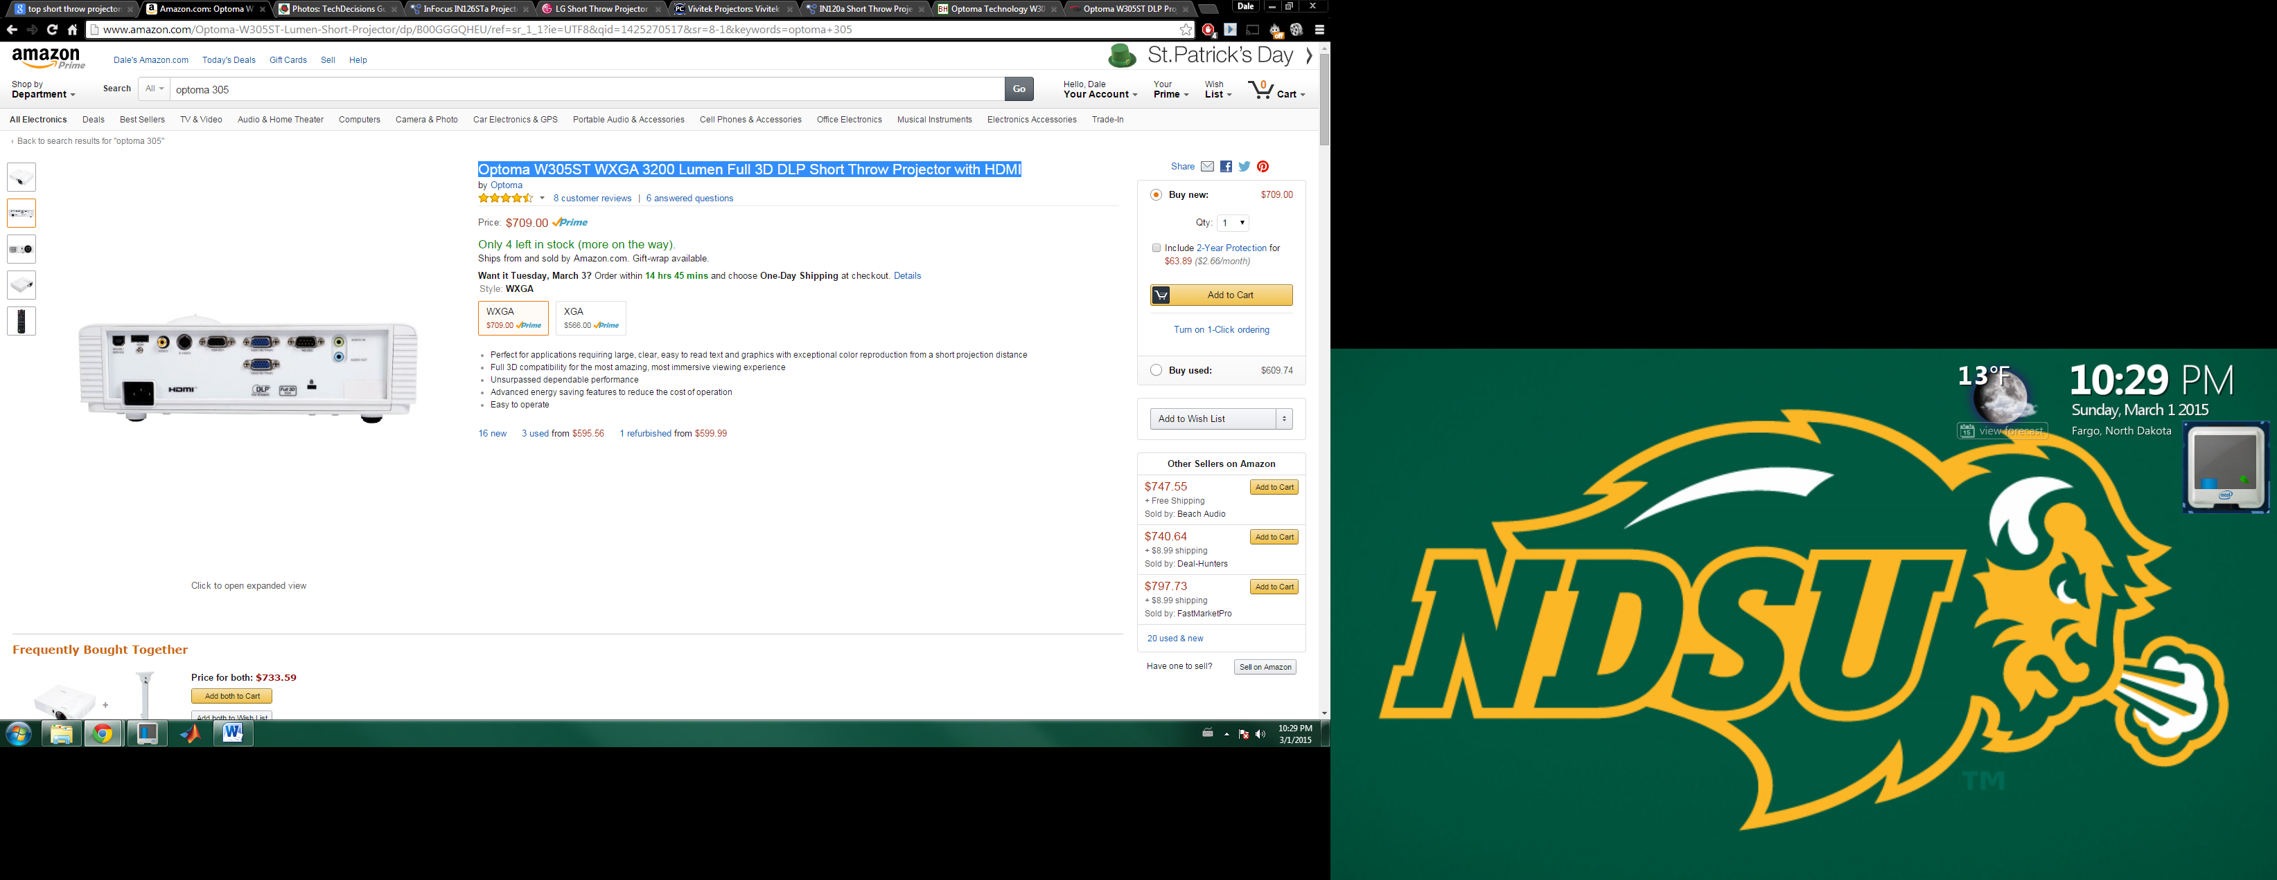Optoma W305ST WXGA 3200 Lumen Full 3D DLP Short Throw Projector with HDMI ($709 WXGA) ($566 XGA)

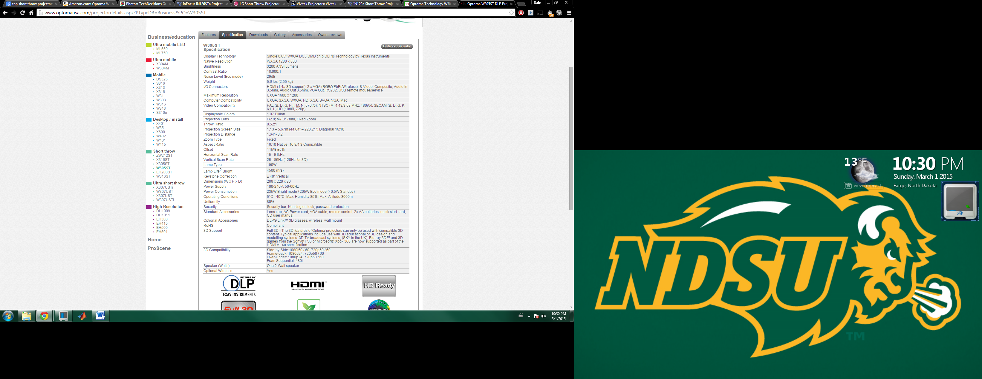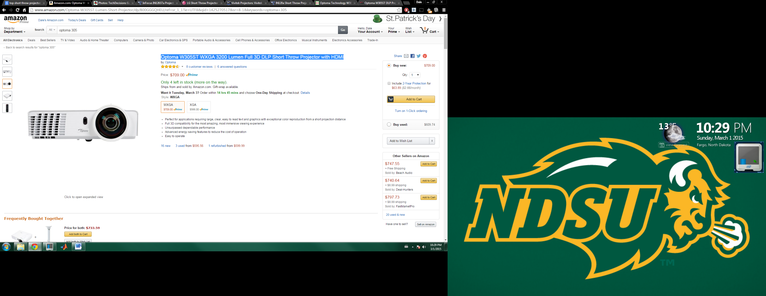

1. AAXA 450 Pico Projector ($449) + (wide angle lens)

This is the projector we wanted to use due to the fact that is extremely small and light weight and has solid specs. The only problem is that it has a throw ratio of 1.4. That means it would have to be 11.2 ft off the surface of the table. If we wanted to use this we’d need a wide angle lens that would work.

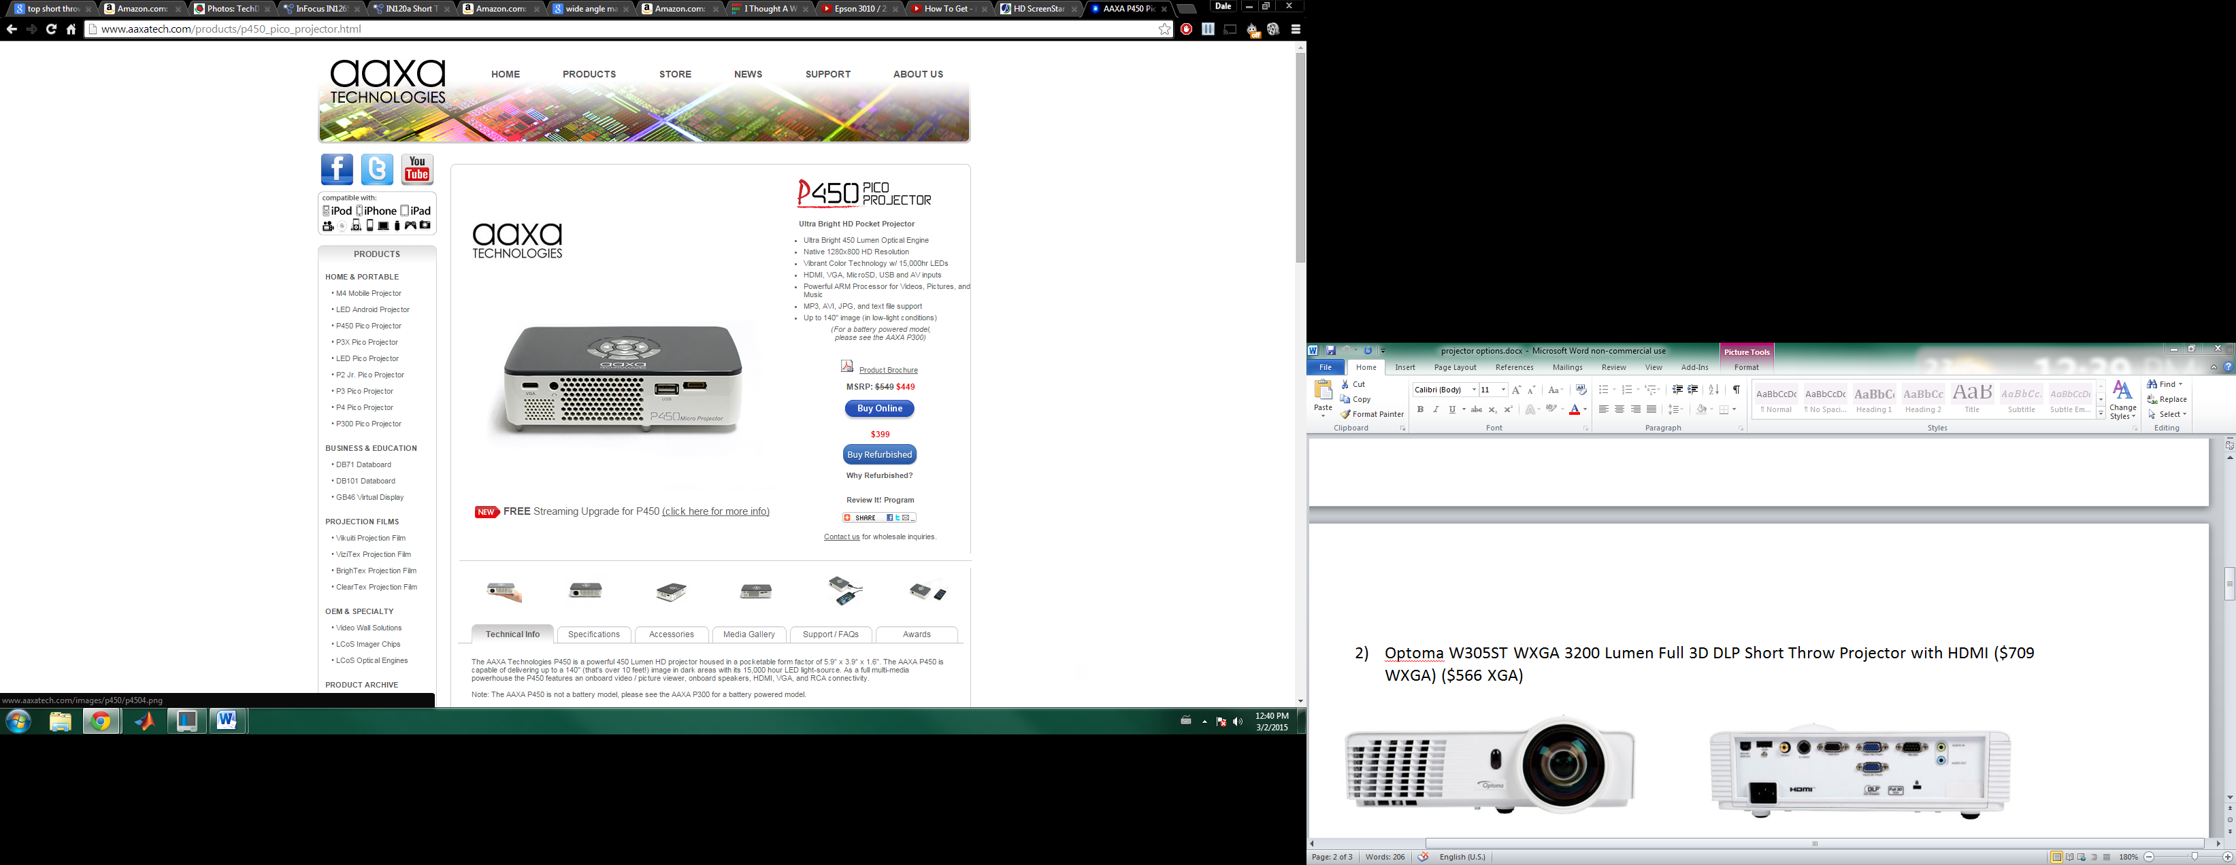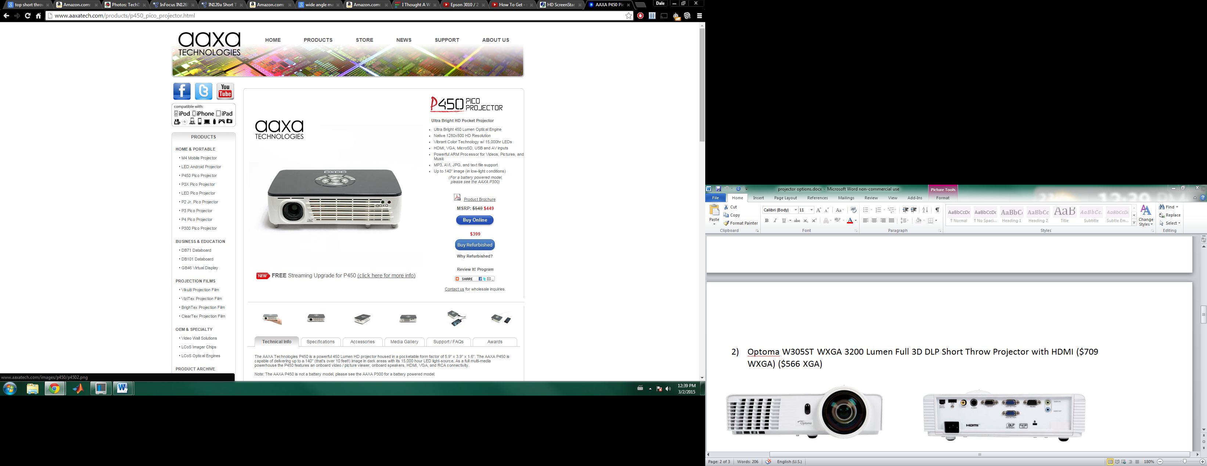

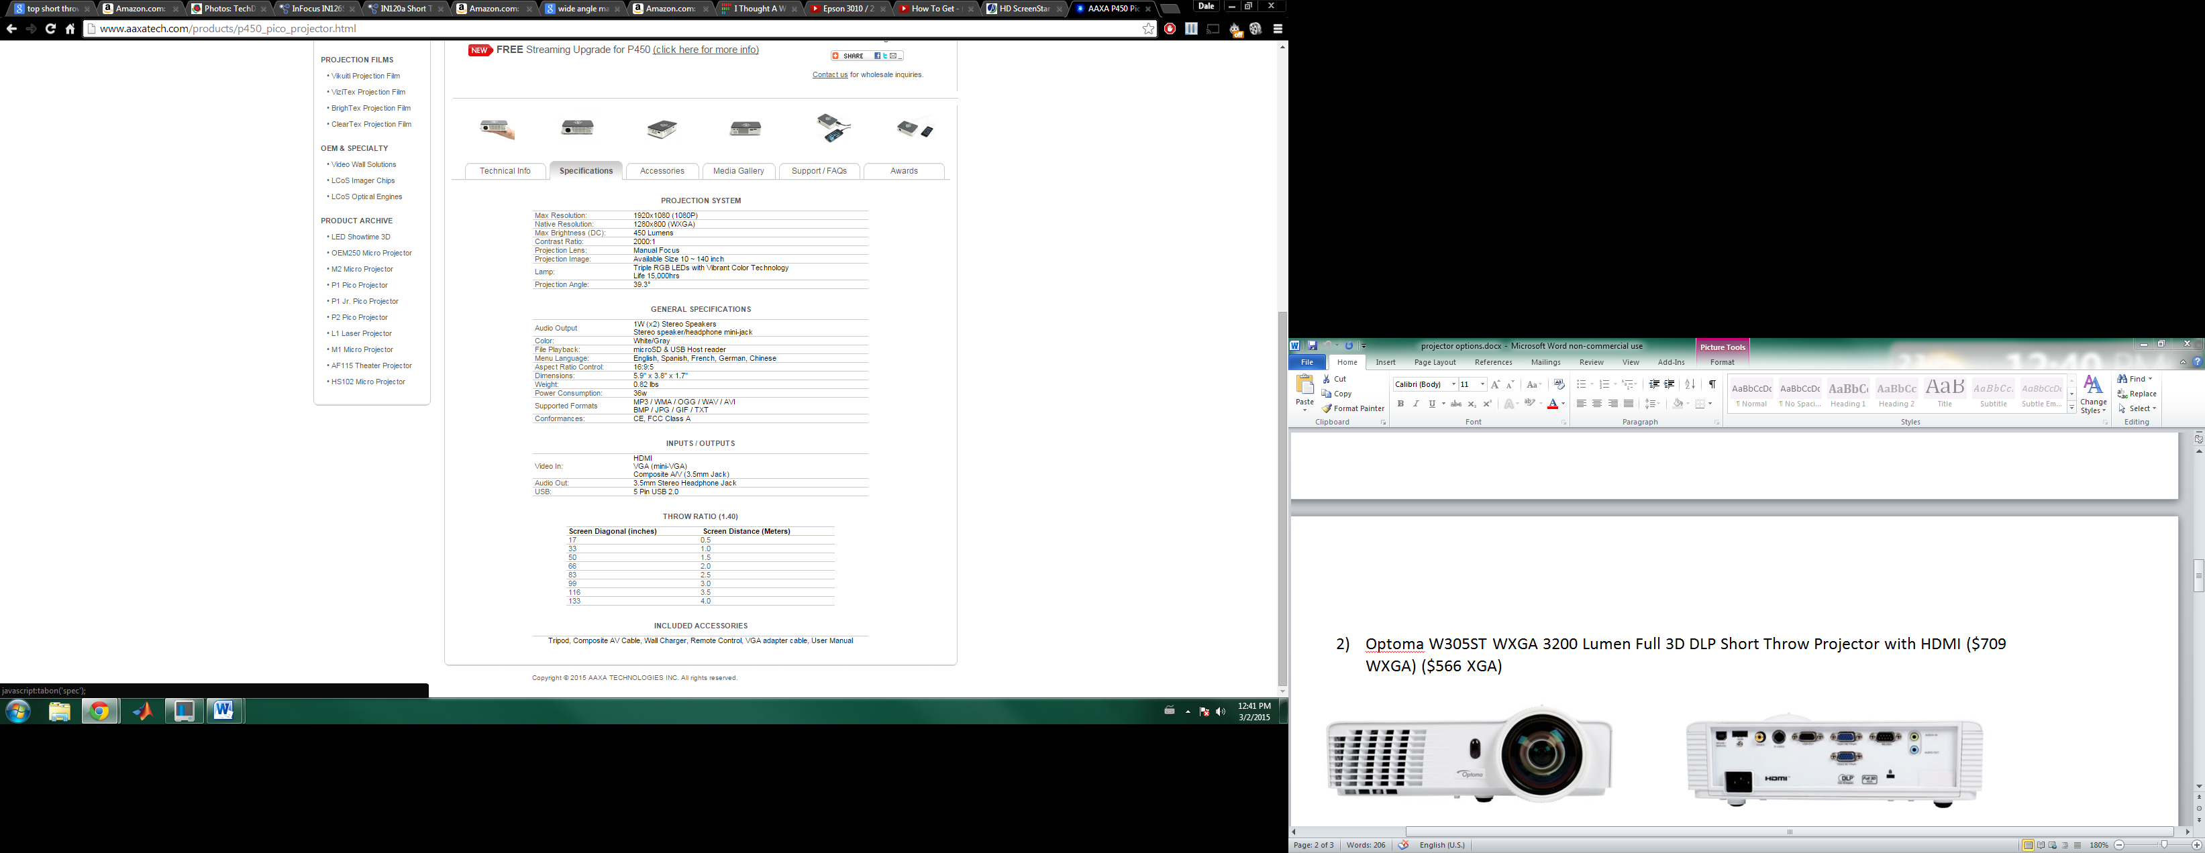

1. InFocus IN126STa ($779)

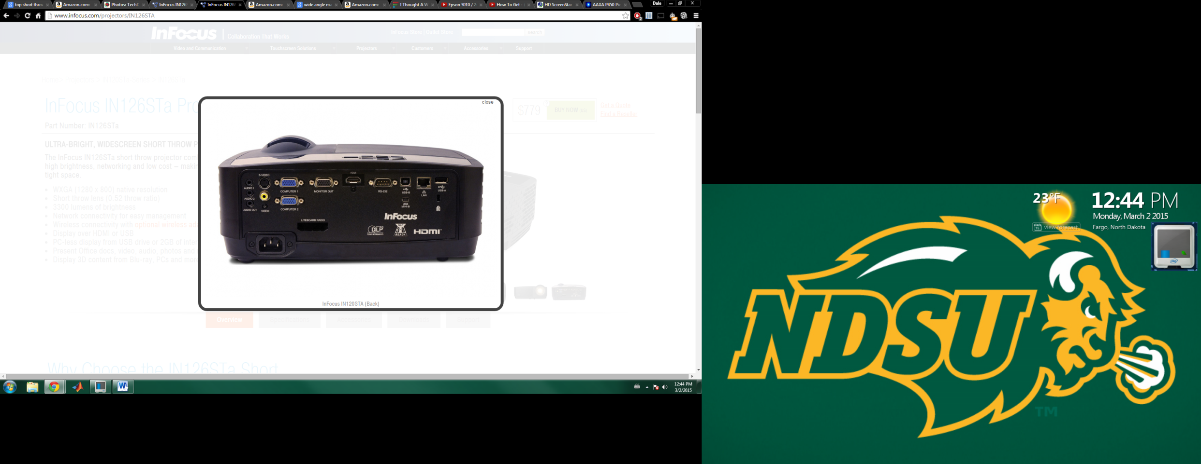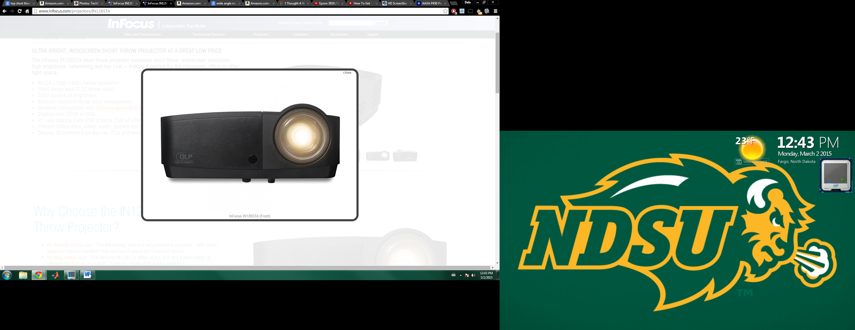

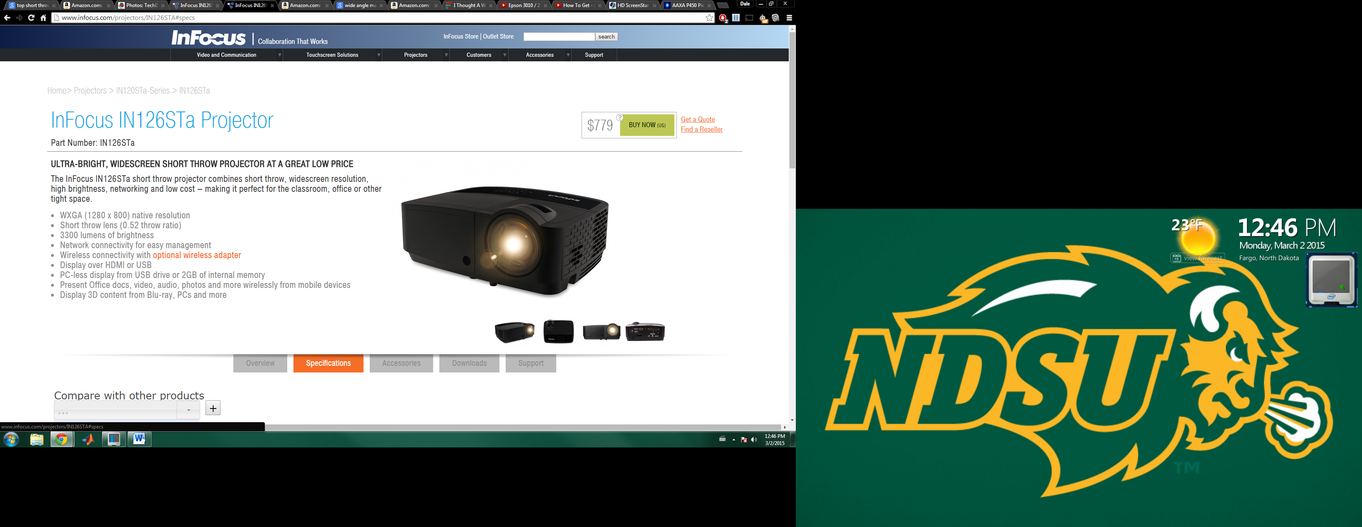

1. Optoma GT1080 ($749)

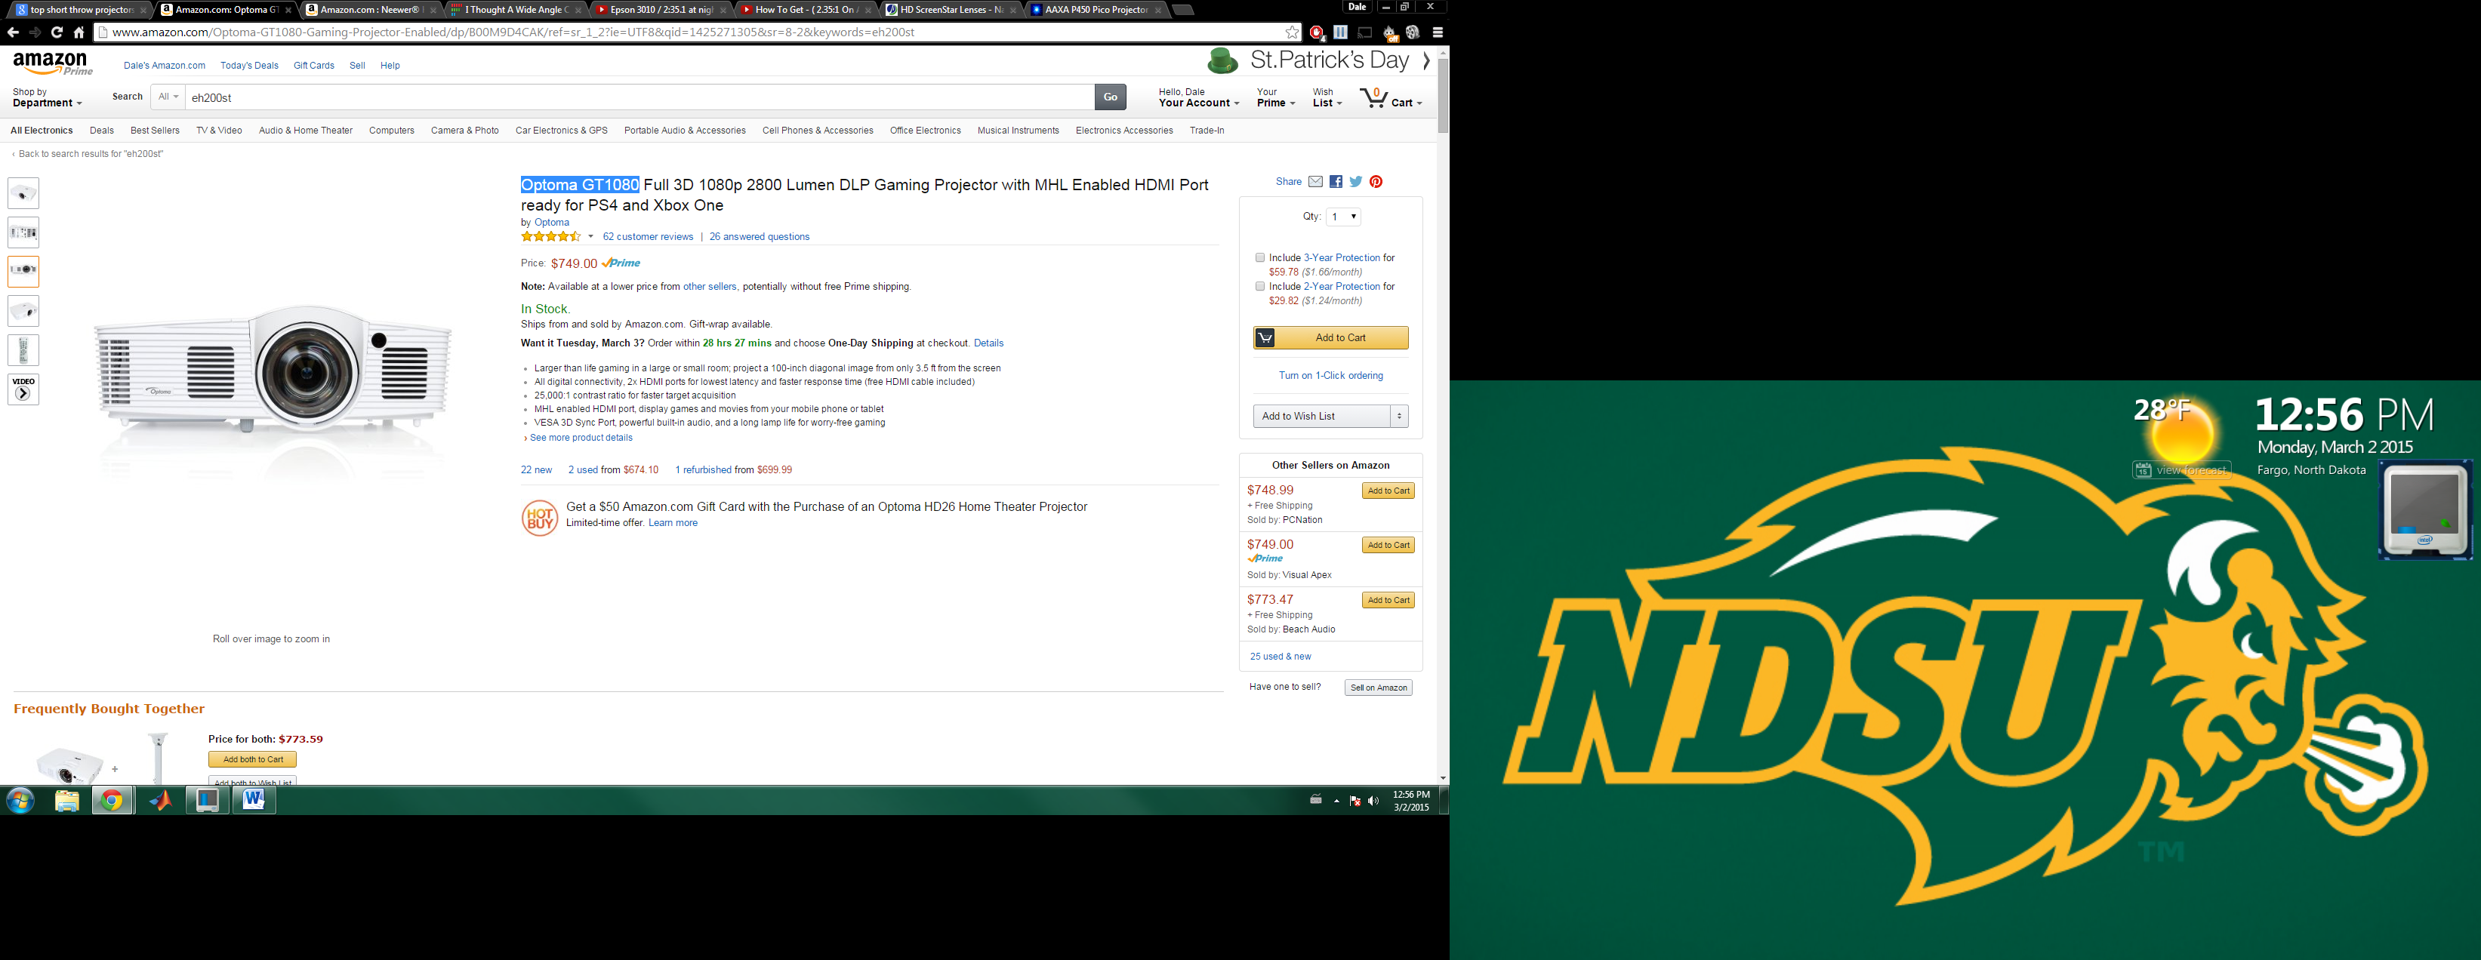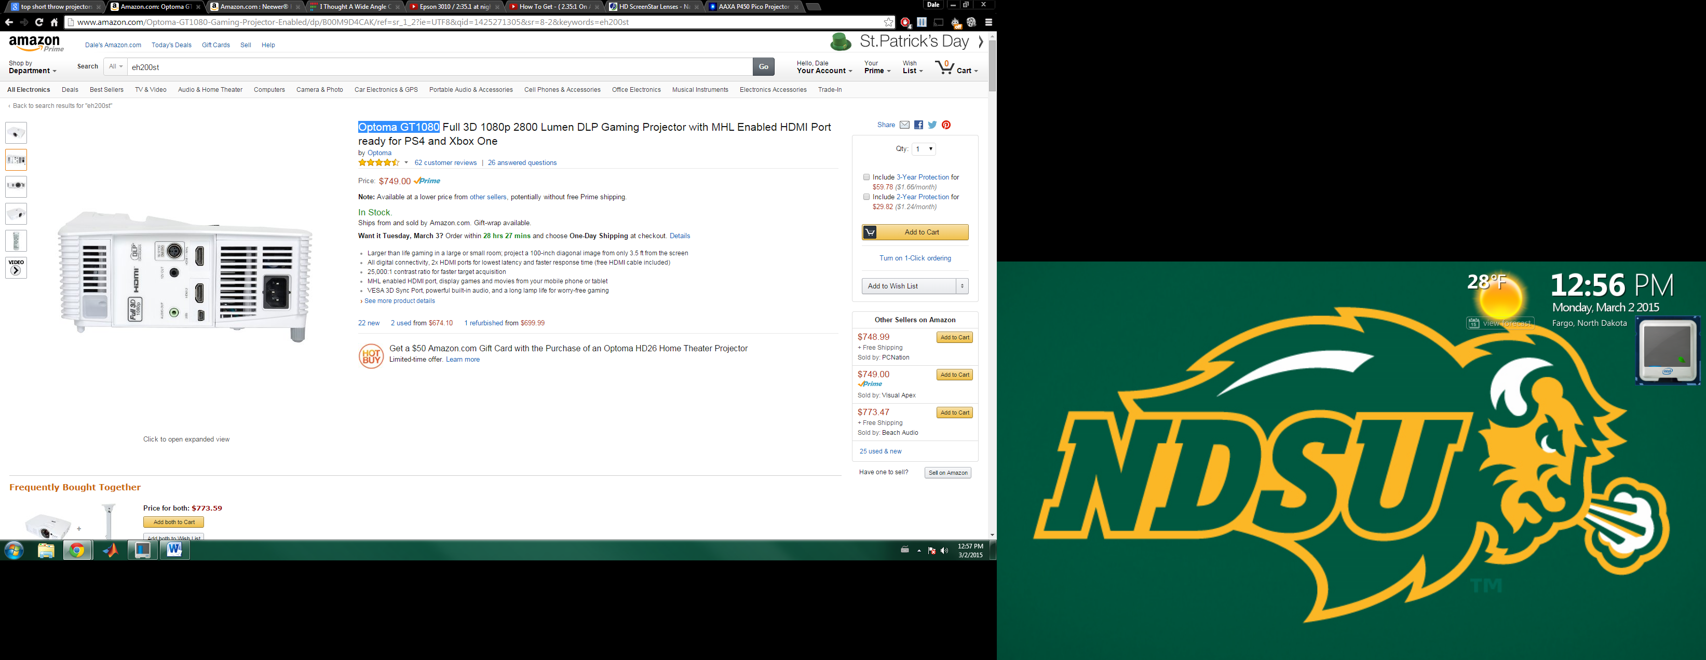

I really like this projector because of cords would connect on the side of the projector and it has a throw ratio of .5 and is relatively lighter.

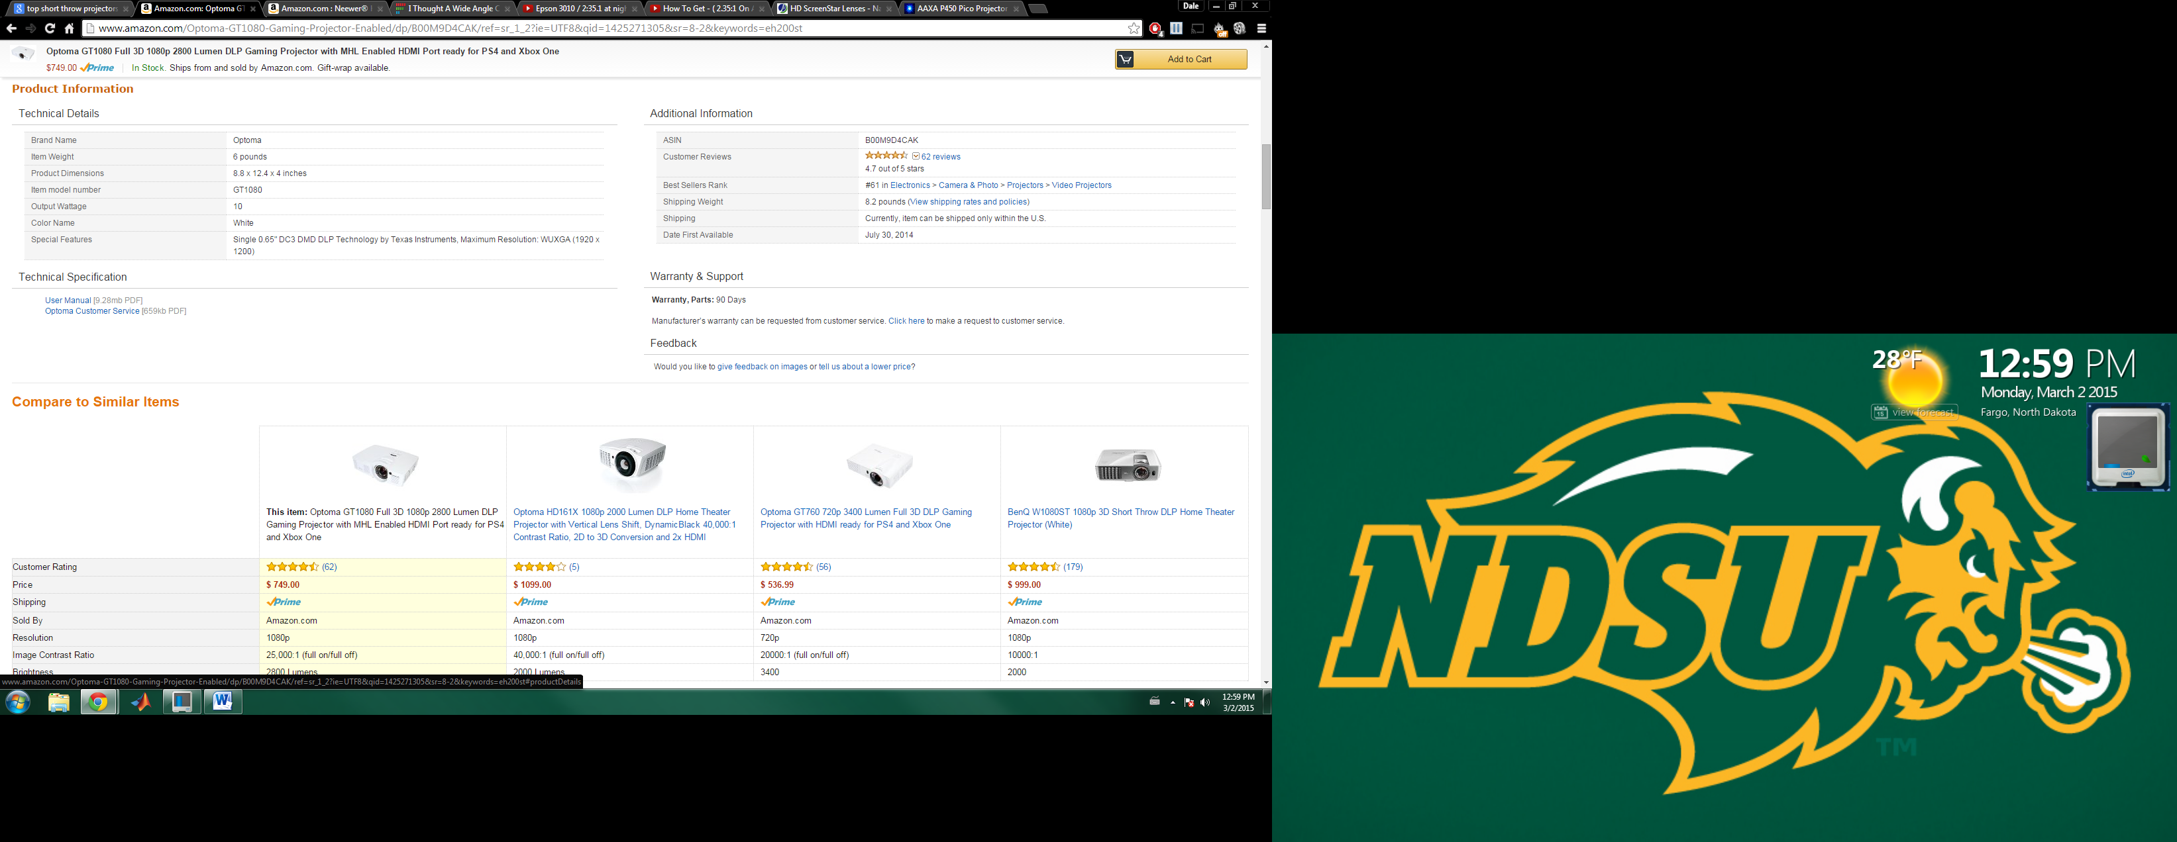

*User Application & Image Processing*

Unity3d Application

Unity is a popular game design engine used by many app developers. It supports a variety of platforms including Android, standalone, and web. The setup of Unity allows both GUI and 3d creation of apps. There are many plugins that allow for more than games to be created. A built in library exists in Unity which allows the user to take a webcam texture and project it anywhere in the app. Python code can be run using user developed plugins.

<http://unity3d.com/>

Python OpenCV

Python is a growing interpreted scripting language that is becoming more popular in industry. It is OOP like other languages such as C# and Java, but is much more basic. Python scripts can be run through the command line making them very useful to Linux environments. There are many existing libraries in Python for image processing. OpenCV combines many different image processing techniques into one tool. It has a lot of user support, and is fairly easy to pick up.

<http://opencv.org/>

Eclipse

Eclipse is an IDE which supports a variety of languages from C to Java. There are many libraries that can be imported into Eclipse. There are a few image processing libraries one of which is Scala. This set of code has been developed a bit, but is not at the same level that OpenCV is. Eclipse also has an android application project option which allows users to create mobile android applications. The UI of the android projects is moderately easy to use, and contains most of the tools necessary to create android applications. There is not quite as much freedom as Unity, but it still has some potential. Eclipse also has a plugin for python development called PyDev. This would allow access to OpenCV or other image processing libraries.

<https://eclipse.org/>

**Options Considered Conclusion**

**Budget**

|  |  |  |  |  |  |
| --- | --- | --- | --- | --- | --- |
| **Part** | **Quantity** | **Retail Cost** | **Expected Cost** | **Total Cost** | **Notes** |
| Samsung Tab S 10.5” | 1 | $499.99 | $499.99 | $499.99 |  |
| P450 Pico Projector | 1 | $449 | $460 | $460 | Option to buy Refurbished for $399 |
|  |  |  |  |  |  |
|  |  |  |  |  |  |
|  |  |  |  |  |  |

**Timeline**

**Summary**

Learning new skills is a fundamental part of human development. Our goal is to assist people in rapidly learning new skills by using augmented reality. Often times it can be hard to know where to place hands or feet when learning a new skill. We believe that a projector can be used to direct a person’s actions thus increasing their ability to learn a new skill. To test this concept we will build a system to teach a person how to play pool. By projecting ball locations and movement, we believe that a person will be able to increase their knowledge of how the physics works.

After carefully researching all of the hardware and software options that we had available to us, we decided to choose a Samsung Galaxy Tab S and p450 mobile projector combo. The Samsung Galaxy Tab S has the specs that we need, and will make a good hardware platform to build upon. The application will be developed in Unity using a combination of C# code, and python plugins utilizing the OpenCV image processing libraries. Unity is an easy to learn, powerful graphics engine which will allow us to create a great application. The projector that we decide to go with is Aaxa’s p450 mobile projector. This projector will allow us to quickly set up our system for any surface, and is a very powerful projector for the price. Another goal of project is for us to make the app compatible with a variety of tablets and projectors.

Successful completion of this project will prove the concept of augmented reality learning of new skills. This would open the door to using the same technique to other skills such as learning how to play the piano, or kicking a soccer ball.